This test contains synoptic questions from some of the previous three topics you’ve covered.

**1** Below is a pie chart showing the composition of the atmosphere today.



**a)** What gas makes up 78% of the atmosphere today? (1)

**b)** What gas makes up 21% of the atmosphere today? (1)

The other gases in today’s atmosphere include carbon dioxide. It is thought that the Earth’s early atmosphere contained about 95% carbon dioxide. One reason for this reduction was the evolution of plants and algae.

**c)** What had to happen before plants could evolve? (2)

**d)** What is the name of the process that produces oxygen from plants? (1)

**e)** What else caused the amount of carbon dioxide to reduce? (1)

Many other gases such as ammonia and methane were in this early atmosphere.

**f)** Where did these gases come from? (1)

**2** Over recent years the amount of carbon dioxide has increased as can be seen in the chart below. Carbon dioxide is a greenhouse gas.

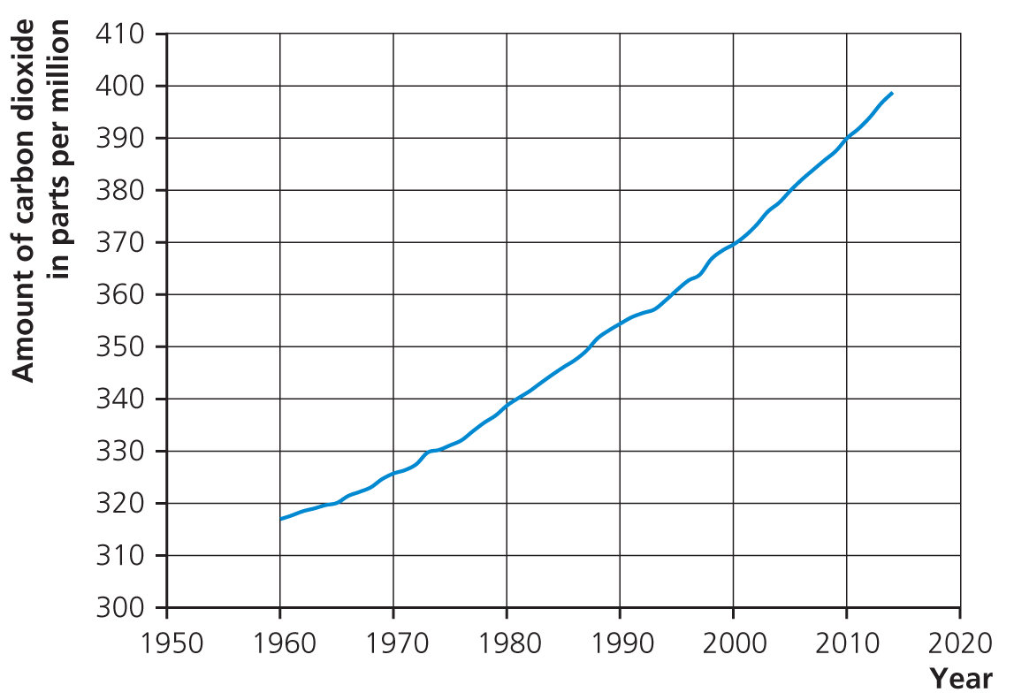

**a)** Carbon dioxide is a greenhouse gas. What effect is caused by greenhouse gases? What does this do to our planet? What is believed to have caused this increase? (6)

**b)** What would happen to the Earth if there were no greenhouse effect? (2)

**3** Biofuels are sometimes described as being ‘carbon neutral’.

**a)** What does this mean? (2)

**b)** Why is it not always completely true? (2)

**4** For the pollutants below, state their cause, the effect they have and how their effect can be reduced:

**a)** Sulfur dioxide (3)

Cause:

Effect:

Reduced:

**b)** Carbon monoxide (3)

Cause:

Effect:

Reduced:

**5**

**a)** What has to happen for a chemical reaction to take place? (2)

The following conditions affect the rate of a chemical reaction. Write a sentence or two to explain, using kinetic theory, how and why the following affect the rate of a chemical reaction.

**b)** Temperature (2)

**c)** Concentration (2)

**d)** Using a catalyst (2)

**6**

**a)** How is crude oil formed? (2)

**b)** How is it separated out into useful products? (2)

Many of the useful products are called alkanes.

**c)** What are the alkanes? (2)

Alkanes are often used as fuels. Propane is a gas used in camping stoves.

**d)** Write the word equation for the reaction of propane with oxygen. (2)

propane + oxygen → _____________ + ________________

**e)** Write the balanced chemical equation for this reaction in excess oxygen. (3)

___C3H8 + ___ O2 → ______________ + _____________

**7**

**a)** What is the test for hydrogen? (1)

**b)** What is the test for oxygen? (1)

Compound A was analysed. It produced a lilac flame with a flame test. When dilute acid was added, a gas was produced which turned limewater cloudy.

**c)** What was compound A? (2)

**d)** What is the formula of this compound? (1)

**e)** What gas turns limewater cloudy? (1)

Total = 50

**1**

**a)** Nitrogen (1)

**b)** Oxygen (1)

**c)** Earth cooled and water condensed (2)

**d)** Photosynthesis (1)

**e)** Carbon dioxide was also decreased by the formation of sedimentary rocks and fossil fuels that contain carbon. (1)

**f)** Volcanoes (1)

**2**

**a)**

|  |  |
| --- | --- |
| **Marks** |  |
| 6–5 | At least three different points well expressed |
| 4–3 | A couple of points mentioned |
| 2–1 | Not much detail |

* Effect is global warming.
* Heat is trapped in Earth’s atmosphere.
* Temperature of planet increases.
* Destroying habitats.
* Sea levels rise.
* Burning fossil fuels cause global warming.
* Deforestation also caused increase in CO2.

**b)** If no greenhouse effect then Earth will be **too cold** for **life to exist**. (2)

**3**

**a)** Carbon neutral = fuels and processes whose use results in zero net release of greenhouse gases to the atmosphere. (2)

**b)** Most need some transportation which use fossil fuels/energy needed to make fuel. (2)

**4**

**a)** Cause: sulfur impurities in fuels (1); Effect: sulfur dioxide causing acid rain (1); Reduced: scrubbers/means of reducing sulfur dioxide from waste gases (1)

**b)** Cause: incomplete combustion (1); Effect: poisonous (1); Reduced: catalytic converters in cars/ensure enough oxygen (1)

**5**

**a)** Particles must **collide** with **sufficient energy**/activation energy. (2)

**b)** Temperature: particles move faster; collide more often and harder; more successful collisions. (2)

**c)** Concentration: more particles in **given volume**; more chance of collision. (2)

**d)** Catalyst: reduces activation energy; more have energy to react; therefore more successful collisions. (2)

**6**

**a)** Crude oil is formed when dead sea creatures fall to bottom of sea. Over millions of years they decompose into oil. (2)

**b)** Separated by: heating oil, put into fractional distillation tower, separate out due to different boiling points. (2)

**c)** Homologous **series** of **hydrocarbons** (2)

**d)** water + carbon dioxide (2)

**e)** C3H8 + **5**O2 → **3CO2** + **4H2O** (3)

**7**

**a)** Squeaky pop (1)

**b)** Relights glowing splint (1)

**c)** Potassium carbonate (2)

**d)** K2CO3 (1)

**e)** CO2 (1)

Total = 50